SYSTEM & MAINTENANCE MANUAL
FOR
WICKET GATE & AUTOMATIC SLIDING GATE

CLIENT: TATA PROJECT LTD
PROJECT: ALSTOM
MFG.YEAR: -

DESIGNED, DEVELOPED & MARKETED
BY



G-BLOCK, 1ST FLOOR, THERMAX CHOWK
MIDC, ABOVE RENAULT SHOWROOM
CHINCHWAD, PUNE-411019

TEL.NO: - +912066304033
EMAIL:-info@nihva.com
www.nihva.com

AUTOMATIC SLIDING GATE
SIZE | 7.2m X 1.8m
SR NO
CLIENT | TATA PROJECT LTD

ABTRACT:

We are pleased to forward this manual to you to provide guidelines on trouble free operation of the equipment, procedures for periodic and preventive maintenance, and troubleshooting. This manual consists of the description of equipment along with technical specifications, and operation procedures. For maintenance of ‘Bought-out’ equipment, please refer manufacturers’ manuals. We insist you to maintain necessary record (logbook) for ensuring proper preventive maintenance, to achieve trouble free production. We are sure; you will find this manual very useful and interesting. However, your suggestions and doubts if any are always welcome!

CONTENTS

- OPERATING & SAFETY INSTRUCTION

- GA DRAWING – WICKET GATE

- GA DRAWING – AUTOMATIC SLIDING GATE

- FOUNDATION DRAWING

- ELECTRICAL CIRCUIT DIAGRAM

- SPARE & WEAR PART LIST

OPERATING & SAFETY INSTRUCTIONS FOR
TELESCOPIC/SLIDING GATE

It is important to make sure everyone that will be using the gate is aware of the following dangers associated with automatic Gates
- Always keep track of the gate clean i.e. dust &Mud free for smooth operation of gate & long life of wheels.
- In case of power failure, please put motor in manual mode by key & then
Slide /operate the leaf manually for opening or closing.
- Operate the gate by only push button when it is in automatic mode.
- Do not contact any part of the gate or walk in the path of the gate while it is moving. Never let children play with the gate controls. Do not attempt to “beat the gate” while it is closing. This is extremely dangerous.
- Ensure proper working of photo sensor for safety purpose or if sensor is not working then contact supplier.
- If using the Auto-close feature it is highly recommended that a Point to Point Photo Electric Safety Beam (Photocell) is installed to prevent the gate closing on any vehicle using the gate.
- Ensure proper working of nylon roller & wheels of gate otherwise get it replaced from manufacturer.
- If push buttons, key switches or Digital Keypads are installed, they should be within sight of the gate but not placed so the user will be tempted to reach through the gate to activate the gate operator.
- Please ensure proper alignment of rack if there is any noise then contact to the supplier.

GA DRAWING: WICKET GATE

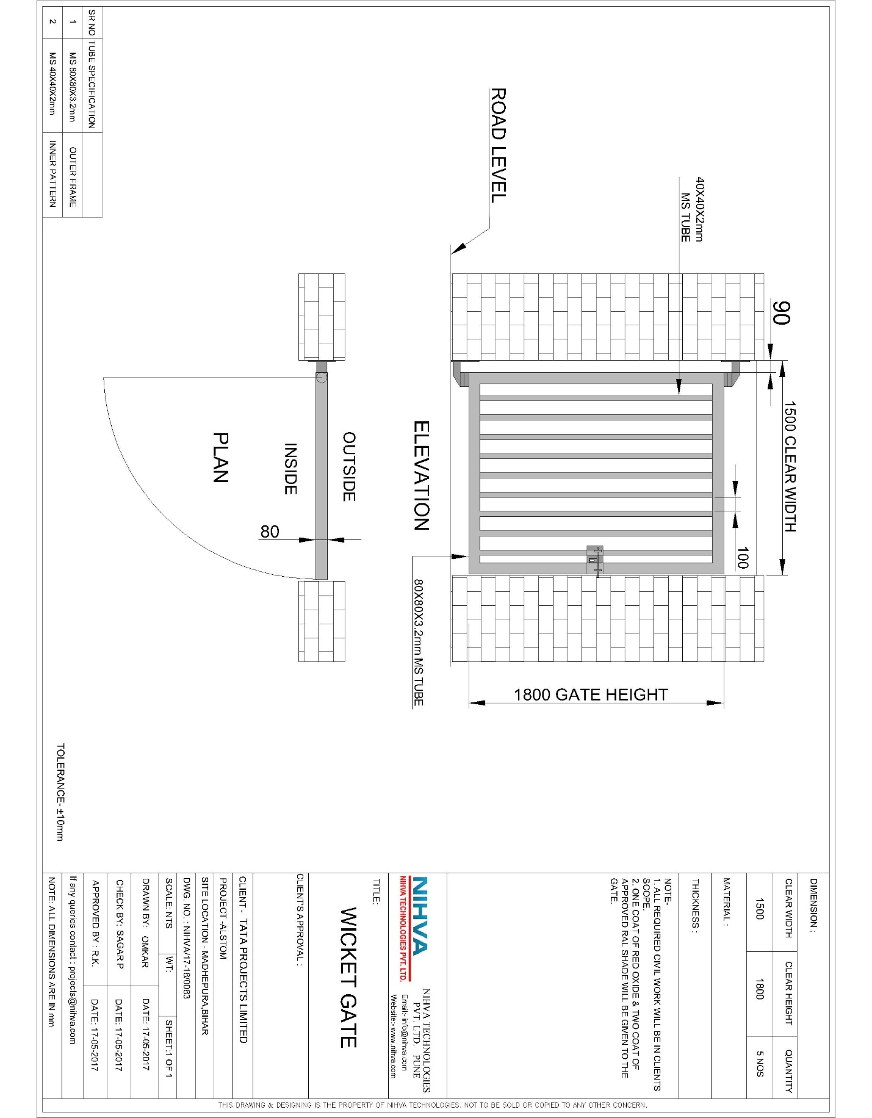
GA DRAWING: AUTOMATIC SLIDING GATE
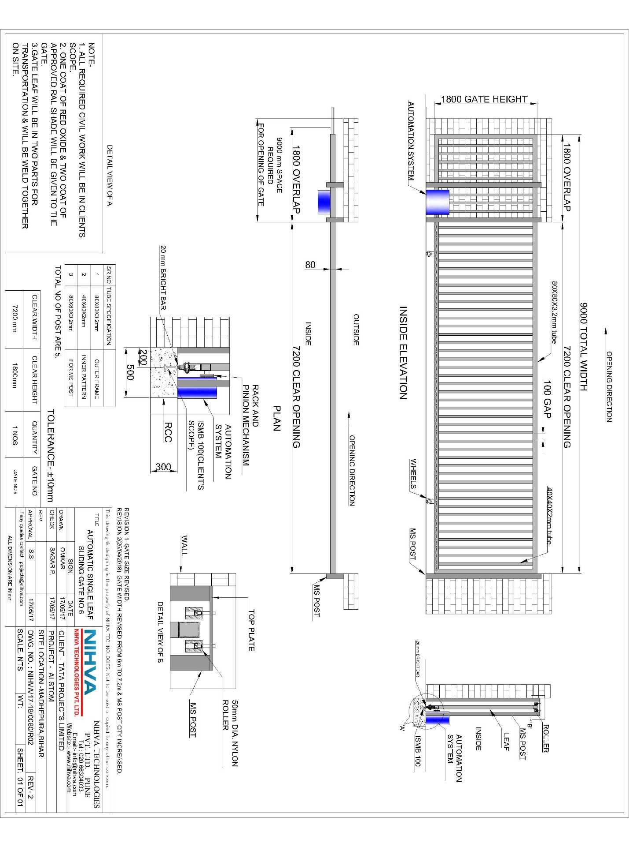
FOUNDATION DRAWING:

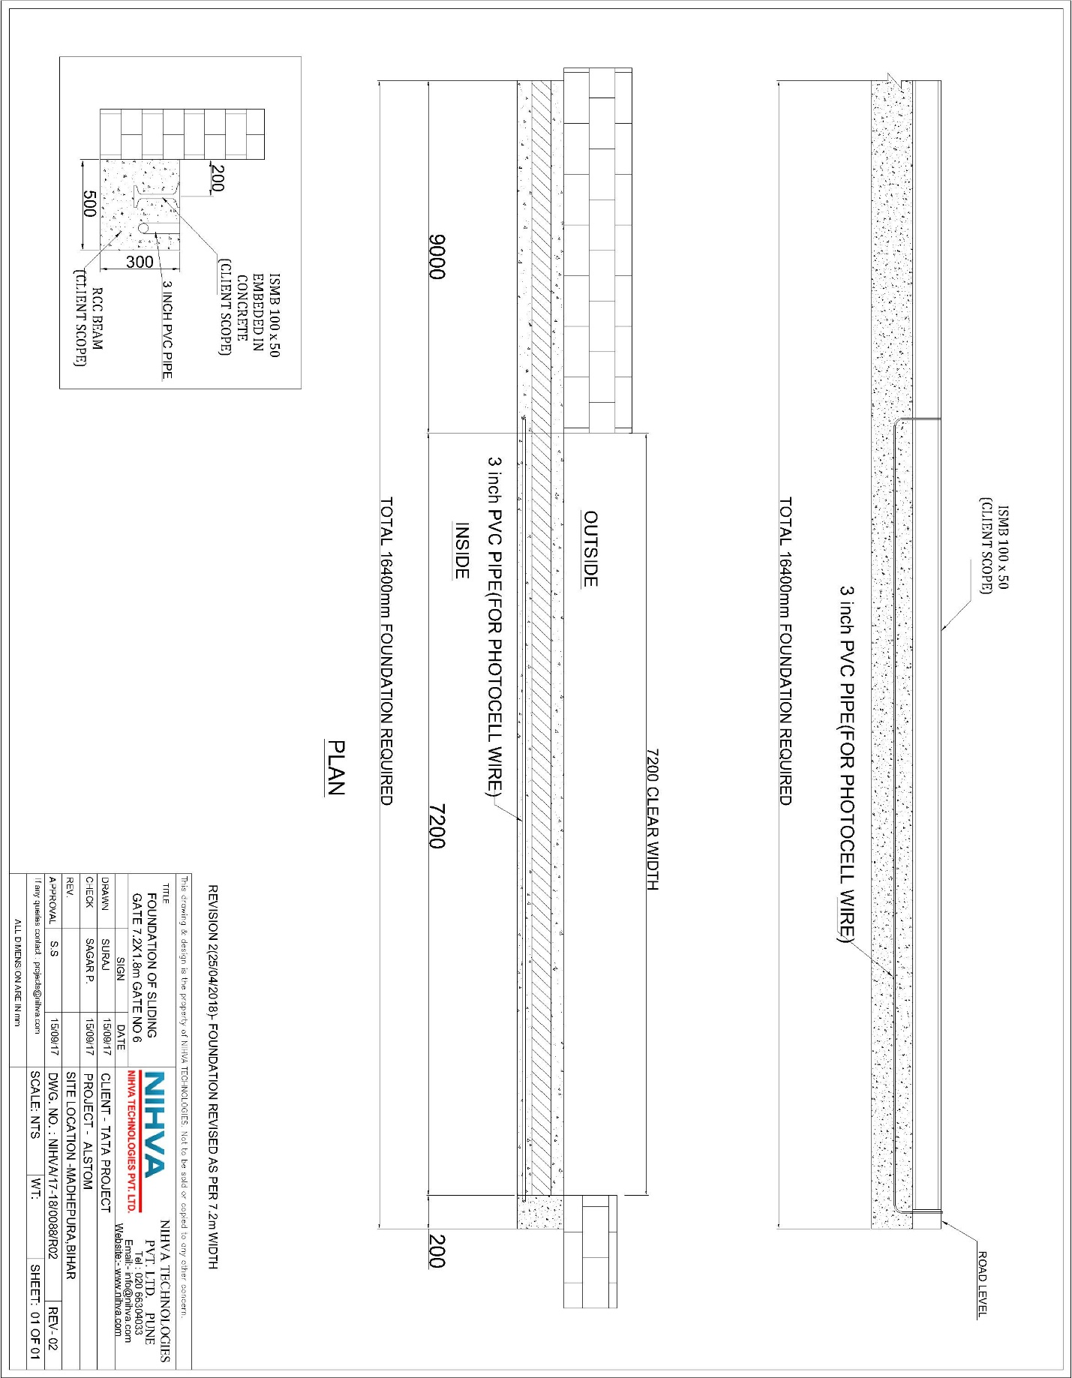
ELECTRICAL CIRCUIT DIAGRAM:

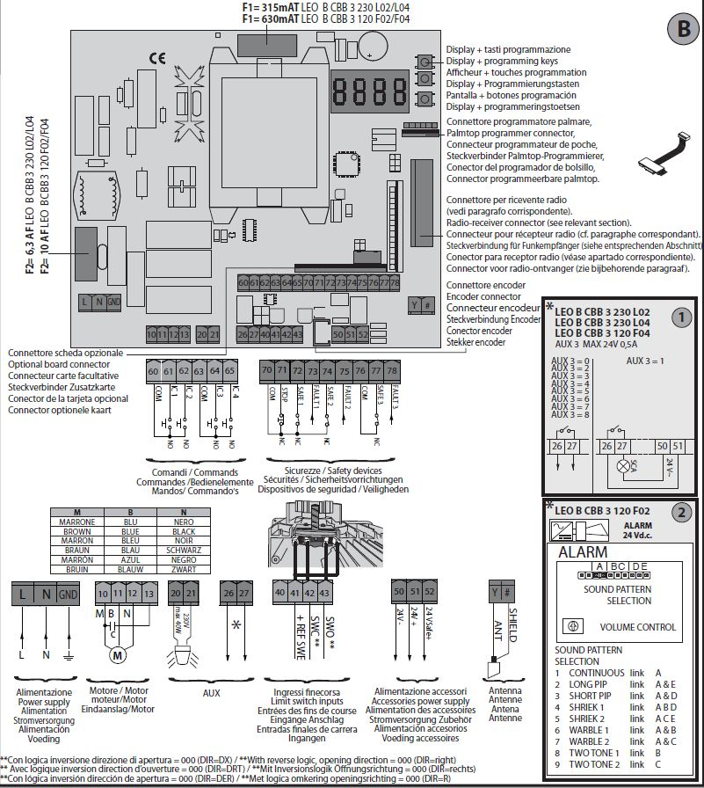
SPARE & WEAR PART LISTS:

S NO | ITEM DESCRIPTION | QTY.
1 | MOTOR | 1
2 | RACK | 1
3 | CONDUIT-1 INCH & 2 INCH | 1
4 | GUIDE ROLLER | 5
5 | GATE M.S WHEEL | 2
6 | PUSH BUTTON PENDENT | 1

